**The Velella Epsilon Project: Pioneering Offshore Aquaculture in the Southeastern Gulf of Mexico**

NEIL A. SIMS

KAMPACHI FARMS, LLC

PO BOX 4239, KAILUA-KONA, HAWAII 96745

neil@kampachifarm.com

LISA D. VOLLBRECHT

KAMPACHI FARMS, LLC

PO BOX 4239, KAILUA-KONA, HAWAII 96745

lisa@kampachifarm.com

DENNIS J. PETERS *

GULFSTREAM AQUACULTURE, LLC

603 WALTON WAY

MIRAMAR BEACH, FLORIDA 32550

DENNIS@GULFSTREAMAQUACULTURE.COM

The Velella Epsilon (VE) Project is an extension of previous projects (Velella Beta-test and Velella Gamma Project) which demonstrated small-scale offshore marine fish culture in the waters of Kona, Hawaii. This VE Project provides a solution to the constraints and misperceptions that currently surround U.S. domestic offshore aquaculture development. Kampachi Farms has shown the potential for demonstration projects to bring about significant changes in community receptivity to offshore aquaculture. The VE Project will adapt the Velella technologies to Gulf of Mexico (GOM) waters, while pursuing two simultaneous efforts: (a) permitting and deployment of a research-scale, demonstration net pen in Federal waters, and in tandem, (b) navigating the commercial permitting process to obtain a commercial offshore aquaculture permit in the GOM, while documenting this effort in a Manual for Aquaculture Permitting Pathway (MAPP).

The VE Project will lay the groundwork for wider acceptance of commercial aquaculture in the GOM region by:

(1) Serving as an educational platform for the promotion of rational aquaculture policies and demystification of the industry, by providing a working net pen example to politicians, constituents, journalists, and other influencers of policy or public perceptions, as well as the local community;

(2) Increasing public awareness of, and receptivity towards, offshore aquaculture and the need to grow more seafood in U.S. waters, by providing public tours of the offshore operation, including (possibly) snorkeling inside the net pen, and fee fishing;

(3) Acting as a demonstration platform for data collection of water quality, potential benthic impacts, and marine mammal and fish stock interactions resulting from offshore aquaculture in the GOM; and

(4) Providing local recreational, charter, and commercial fishing communities with evidence of the benefits of aquaculture, through the Fish Aggregation Device (FAD) effects of the project, and by documentation of fish aggregation and fishing boat activity around the VE Project.

The VE Project focuses on a small, pilot-scale (single net pen) aquaculture system where up to 20,000 almaco jack (kampachi; *Seriola rivoliana*) fingerlings would be reared for approximately 12 months in Federal waters around 40 nautical miles west southwest of Sarasota, Florida. An extensive siting analysis was performed to determine the optimal location for this research-scale demonstration project. Alternative offshore sites (Sarasota and south) were identified that provide sufficiently warm ***water temperatures*** throughout most of the year (March – December). Site locations were further refined to ensure adequate ***water depths*** (40 meters [m]/132 feet [ft] minimum) while retaining a workable distance from shore. This minimum depth is needed for the submersible net pen system to withstand the current and wave energies associated with tropical storms and hurricanes. Equally important to achieving optimal environmental conditions were the efforts to deconflict this demonstration project’s location from ***other GOM user-groups*** within the same vicinity. To this end, Kampachi staff engaged early in the planning process with stakeholder outreach initiatives, particularly with the recreational and commercial fishing industry, to forge relationships for better understanding of their critical fishing areas of the GOM. Through an iterative process, a subset of alternative site locations were further refined which were mutually agreeable to the commercial shrimping industry and the proposed operations of the VE Project. Similarly, a working partnership with NOAA’s National Ocean Service ensured that the Department of Defense’s military interests and activities to the south of the proposed alternative sites would not be in conflict with those proposed by the VE Project.

* Presenter

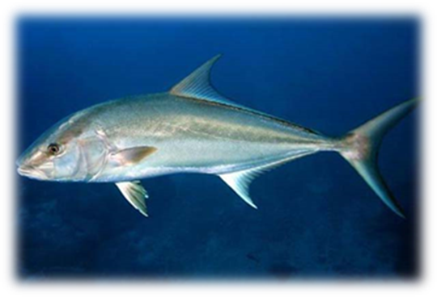

**Adult kampachi; *Seriola rivoliana***

The National Ocean Service performed an extensive siting analysis utilizing their ***Gulf AquaMapper***, which further ensured that other important and ***sensitive marine resources*** were avoided; including coral reefs and hardbottoms; anthropogenic structures (shipwrecks and other cultural resources); and other essential fish habitat features. Site selection was finalized by conducting an extensive baseline environmental survey that included the deployment and analyses of single beam bathymetry, side scan sonar, sub-bottom profile (seismic reflection), magnetometer, and hydrographic data. After multiple interagency reviews, close coordination, and an archaeological evaluation, the project received compliance concurrences from the Florida State Historic Preservation Office (SHPO) for the National Historic Preservation Act (NHPA); Section 106 and from the Florida Department of Environmental Protection (FDEP), Florida State Clearinghouse for the Coastal Zone Management Act (CZMA).

The VE Project will utilize a multi-anchor (3) swivel (MAS)-point mooring that provides a defined fore and aft of the net pen, thus ensuring a unidirectional current, critical for optimizing fish health. This MAS-point mooring configuration also allows for wider dispersal of nutrients over the full 360-degree watch-circle of the array, dramatically reducing the potential for any impacts on water quality or benthos. After shipment, assembly, and deployment from Port Manatee, Tampa Bay, Florida, the1,600 m3 net pen and mooring infrastructure will be installed at the preferred site location (approximately at 27.119580°N, 83.197095°W) off Sarasota, Florida, where it will be tended (i.e., research trawler) and staffed (i.e., captain, manager, and technicians) around the clock for the duration of the project. The VE Project plans to utilize a brass (copper-zinc alloy) net mesh material (similar to that used in the Velella Beta-Test and Gamma-Test), that will markedly reduce the biofouling on the pen, and thereby improve water exchange and fish health, while virtually eliminating the risk of marine mammal entanglement and virtually eliminating the risk of net breaches by predators such as sharks or marine mammals.

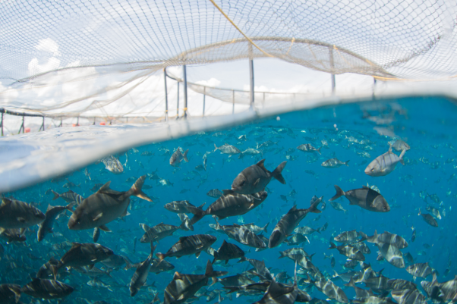

**Kampachi culture; La Paz, Mexico**

Kampachi fingerlings will be provided from either Mote Aquaculture Park (Mote) or the University of Miami, Rosenstiel School of Marine and Atmospheric Science (RSMAS). These first-generation offspring will be produced from indigenous broodstock being maintained at Mote that were originally caught from local GOM waters off Madeira Beach, Florida. After transport and stocking to the VE Project site, the fish will be cultured offshore to a size of around 2 kilograms (kg) or 4.4 pounds (lbs) by time of harvest. VE Project technicians will conduct extensive environmental monitoring, as dictated by the U.S. Environmental Protection Agency’s (USEPA), National Pollutant Discharge and Elimination System (NPDES) permit requirements. Compliance monitoring will include a suite of water quality parameters as well as sediment and benthic macroinfauna community sampling, to be conducted at a variety of locations fore, under, and aft of the net pen array. Routine schedules will be established for compliance reporting, monitoring, and record keeping. Similarly, in compliance with NOAA’s National Marine Fisheries Service (NMFS), Endangered Species Act (ESA) consultation requirements, VE Project’s protected species observers will conduct extensive marine mammal and other protected and sensitive species monitoring and reporting in order to capture observations of species’ interactions and potential impacts associated with the VE Project’s operations.

With an anticipated 85 percent (%) survival rate, it is estimated that 17,000 fish or 34,000 kg/74,800 lbs will be harvested during months 11 and 12. VE Project staff will further partner with the recreational and commercial fishing industry to use the expertise, fishing vessels, and infrastructure of the working waterfront to perform the harvesting, processing, and shipment for landing of the kampachi product on Florida shores. These fish will be marketed and sold to state- and Federally-licensed dealers, in accordance with state (an Aquaculture Certificate of Registration via Florida Department of Agriculture and Consumer Services [FDACS]) and Federal law.

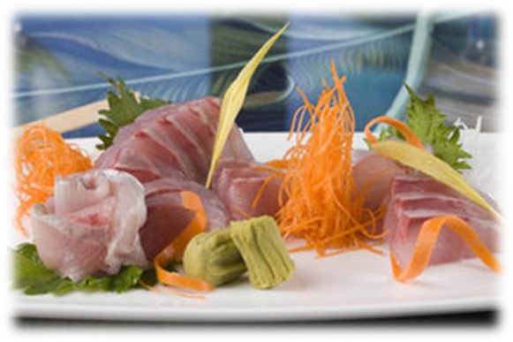

**Kampachi sashimi**

The U.S. currently has no commercial aquaculture operations in Federal waters. The industry stakeholders recognize that marine aquaculture regulations are complex, involving multiple agencies, laws, regulations, and jurisdictions. Permitting processes are time-consuming and difficult to navigate, significantly limiting access to sites, and highly discouraging of entrepreneurs and investors. To address these challenges, the VE Project will pursue an application for a commercial aquaculture permit in GOM waters off southwest Florida, and document the process for future applicants to follow, including recording of the effort, the challenges, the agencies and compliance requirements, and the overall timeline. The VE Project will document (MAPP) the processing of the various permit requests for each agency; will work with the various agencies to identify areas needing further regulation, clarification of the agency requirements, or elimination of duplication of efforts or other redundancies; and will make the National Environmental Policy Act (NEPA) contributions and other supporting consultation and permit documents readily available for future permit applicants to use as a template.

While pioneering the pathway to commercial viability for an offshore net pen operation, the VE Project will determine (a) the market price and any premium for offshore-grown GOM aquaculture products; (b) the appeal to local and tourist fisherfolk for fee fishing in the net pen, and the potential revenues that might be attained on a commercial scale; (c) the appeal to tourists for offshore farm tours, including (possibly) snorkeling or SCUBA diving inside or around the VE Project net pen array, and (d) the potential to improve marketability of offshore-grown fish by increasing public awareness of and support for the project. As with Kampachi’s parent operations in La Paz, Mexico, commercial operations in the U.S. will vigorously pursue Aquaculture Stewardship Council (ASC) certification for environmentally and socially responsible seafood production.

------------- /// -------------